**Scientific Journal TURBO**

**PUBLICATION ETHICS**

Scientific Journal TURBO is an Open Access journal published by Romanian Research and Development Institute for Gas Turbines COMOTI. We publish peer-reviewed articles biannually and it is important to specify that we comply with standards of ethical behavior regarding all parties involved in articles publishing stages: authors, editors, peer-reviewers, publishers.

All the publication ethics which we respect are based on:

* COPE’s Principles of Transparency and Best Practice in Scholarly Publishing (<https://publicationethics.org/files/Principles%20of%20Transparency%20and%20Best%20Practice%20in%20Scholarly%20Publishing_0.pdf> );
* COPE’s Code of Conduct and Best Practice Guidelines for Journal Editors (<https://publicationethics.org/files/Code%20of%20Conduct.pdf> );
* COPE’s Code of Conduct for Journal Publishers (<https://publicationethics.org/files/Code%20of%20conduct%20for%20publishers%20FINAL_1_0.pdf> );
* ELSEVIER’s Ethical Guidelines for Journal Publication (<https://www.elsevier.com/__data/assets/pdf_file/0009/300888/Ethical-guidelines-for-journal-publication-V2.0-May-2017-Elsevier.pdf> );
* JOHN WILEY & SONS Best Practice Guidelines on Publishing Ethics. A Publisher’s Perspective, Second Edition, 2014 (<https://authorservices.wiley.com/asset/Best-Practice-Guidelines-on-Publishing-Ethics-2ed.pdf> ).

**Duties of Authors**

**Reporting Standards**

Authors of reports of original research should present an accurate account of the work performed as well as an objective discussion of its significance. Underlying data should be represented accurately in the paper. A paper should contain sufficient detail and references to permit others to replicate the work. Fraudulent or knowingly inaccurate statements constitute unethical behavior and are unacceptable. Review and professional publication articles should also be accurate and objective, and editorial opinion works should be clearly identified as such.

**Data Access and Retention**

Authors may be asked to provide the research data supporting their paper for editorial review and/or to comply with the open data requirements of the journal. Authors should be prepared to provide public access to such data, if practicable, and should be prepared to retain such data for a reasonable number of years after publication.

**Originality and Acknowledgement of Sources**

The authors should ensure that they have written entirely original works, and if the authors have used the work and/or words of others, which this has been appropriately cited or quoted and permission has been obtained where necessary.

Proper acknowledgment of the work of others must always be given. Authors should cite publications that have influenced the reported work and that give the work appropriate context within the larger scholarly record. Information obtained privately, as in conversation, correspondence, or discussion with third parties, must not be used or reported without explicit, written permission from the source.

Plagiarism takes many forms, from “passing off” another’s paper as the author’s own paper, to copying or paraphrasing substantial parts of another’s paper (without attribution), to claiming results from research conducted by others. Plagiarism in all its forms constitutes unethical behavior and is unacceptable.

**Multiple, Redundant or Concurrent Publication**

An author should not in general publish manuscripts describing essentially the same research in more than one journal or primary publication. Submitting the same manuscript to more than one journal concurrently constitutes unethical behavior and is unacceptable. In general, an author should not submit for consideration in another journal a paper that has been published previously, except in the form of an abstract or as part of a published lecture or academic thesis or as an electronic preprint.

Publication of some kinds of articles in more than one journal is sometimes justifiable, provided certain conditions are met. The authors and editors of the journals concerned must agree to the secondary publication, which must reflect the same data and interpretation of the primary document. The primary reference must be cited in the secondary publication.

**Confidentiality**

Information obtained in the course of confidential service, such as refereeing manuscripts or grant applications, must not be used without the explicit written permission of the author of the work involved in these services.

**Authorship of the Paper**

Authorship should be limited to those who have made a significant contribution to the conception, design, execution, or interpretation of the reported study. All those who have made significant contributions should be listed as co-authors. Where there are others who have participated in certain substantive aspects of the paper, they should be recognized in the acknowledgement section. The corresponding author should ensure that all appropriate co-authors and no inappropriate co-authors are included on the paper, and that all co-authors have seen and approved the final version of the paper and have agreed to its submission for publication.

Authors are expected to consider carefully the list and order of authors before submitting their manuscript and provide the definitive list of authors at the time of the original submission. Only in exceptional circumstances will the Editor consider the addition, deletion or rearrangement of authors after the manuscript has been submitted and the author must clearly flag any such request to the Editor. All authors must agree with any such addition, removal or rearrangement.

Authors take collective responsibility for the work. Each individual author is accountable for ensuring the questions related to the accuracy or integrity of any part of the work are appropriately investigated and resolved.

**Hazards and Human / Animal Subjects**

If the work involves chemicals, procedures or equipment that have any unusual hazards inherent in their use, the author must clearly identify these in the manuscript. If the work involves the use of animal or human subjects, the author should ensure that the manuscript contains a statement that all procedures were performed in compliance with relevant laws and institutional guidelines and that the appropriate institutional committees has approved them. Authors should include a statement in the manuscript that informed consent was obtained for experimentation with human subjects. The privacy rights of human subjects must always be observed.

**Disclosure and conflicts of interest**

All authors should disclose in their manuscript any financial and personal relationships with other people or organizations that could be viewed as inappropriately influencing their work.

All sources of financial support for the research and/or preparation of the article should be disclosed, as should the role of the sponsor(s), if any, in study design in the collection, analysis and interpretation of data; in the writing of the report; and in the decision to submit the article for publication. If the funding source(s) had no such involvement then this should be stated.

**Fundamental errors in published works**

When an author discovers a significant error or inaccuracy in his/her own published work, it is the author’s obligation to promptly notify the journal editor or publisher and cooperate with the editor to retract or correct the paper. If the editor or the publisher learns from a third party that a published work contains a significant error, it is the obligation of the author to promptly retract or correct the paper or provide evidence to the editor of the correctness of the original paper.

**Image Integrity**

It is not acceptable to enhance, obscure, move, remove, or introduce a specific feature within an image. Adjustments of brightness, contrast, or color balance are acceptable if and as long as they do not obscure or eliminate any information present in the original. Manipulating images for improved clarity is accepted, but manipulation for other purposes could be seen as scientific ethical abuse.

**Duties of Editors**

**General duties and responsibilities**

• actively seek the views of authors, readers, reviewers and editorial board members about ways of improving their journal’s processes

• encourage and be aware of research into peer review and ‘journalology’ and reassess journal processes in the light of new findings

• support initiatives designed to reduce academic misconduct

• support initiatives to educate researchers about publication ethics

• assess the effects of their journal policies on author and reviewer behavior and revise policies, as required, to encourage responsible behavior and discourage misconduct

• ensure that any press releases issued by the journal reflect the message of the reported article and put it into context.

**Relations with readers**

• ensure that all published reports of research have been reviewed by suitably qualified reviewers

• ensure that non-peer-reviewed sections of their journal are clearly identified

• adopt processes that encourage accuracy, completeness and clarity of research reporting

• consider developing a transparency policy to encourage maximum disclosure about the provenance of non-research articles

• adopt authorship or contributorship systems that promote good practice (i.e. so that listings accurately reflect who did the work) and discourage misconduct (e.g. ghost and guest authors)

• inform readers about steps taken to ensure that submissions from members of the journal’s staff or editorial board receive an objective and unbiased evaluation

**Relations with authors**

• publish clear instructions in the journal about submission and what they expect from authors

• provide guidance about criteria for authorship and/or who should be listed as a contributor

• review author instructions regularly and provide links to relevant guidelines

• require all contributors to disclose relevant competing interests and publish corrections if competing interests are revealed after publication

• ensure that appropriate reviewers are selected for submissions

• respect requests from authors that an individual should not review their submission, if these are well-reasoned.

**Editorial and peer-review processes**

• ensure that people involved with the editorial process (including themselves) receive adequate training and keep

abreast of the latest guidelines, recommendations and evidence about peer review and journal management

• keep informed about research into peer review and technological advances

• adopt peer-review methods best suited for their journal and the research community it serves

• review peer-review practices periodically to see if improvement is possible.

**Duties of Reviewers**

**Contribution to editorial decisions**

Peer review assists the editor in making editorial decisions and through the editorial communications with the author may also assist the author in improving the paper. Peer review is an essential component of formal scholarly communication and lies at the heart of the scientific method. In addition to the specific ethics-related duties, reviewers are asked generally to treat authors and their work as they would like to be treated themselves and to observe good reviewing etiquette.

Any selected referee who feels unqualified to review the research reported in a manuscript or knows that its prompt review will be impossible should notify the editor and excuse himself from the review process.

**Confidentiality**

Any manuscripts received for review must be treated as confidential documents. Reviewers must not share the review or information about the paper with anyone or contact the authors directly without permission from the editor.

Some editors encourage discussion with colleagues or co-reviewing exercises, but reviewers should first discuss this with the editor in order to ensure that confidentiality is observed and that participants receive suitable credit.

Unpublished materials disclosed in a submitted manuscript must not be used in a reviewer’s own research without the express written consent of the author. Privileged information or ideas obtained through peer review must be kept confidential and not used for personal advantage.

**Ethical Issues**

A reviewer should be alert to potential ethical issues in the paper and should bring these to the attention of the editor, including any substantial similarity or overlap between the manuscript under consideration and any other published paper of which the reviewer has personal knowledge. Any statement that an observation, derivation, or argument has been previously reported should be accompanied by the relevant citation.

**Standards of Objectivity and Conflict of Interest**

Reviews should be conducted objectively. Reviewers should be aware of any personal bias they may have and take this into account when reviewing a paper.

Personal criticism of the author is inappropriate. Referees should express their views clearly with supporting arguments. Reviewers should consult the Editor before agreeing to review a paper where they have potential conflicts of interest resulting from competitive, collaborative, or other relationships or connections with any of the authors, companies, or institutions connected to the papers.

**What to do if a reviewer suspects undisclosed conflict of interest in a submitted manuscript**

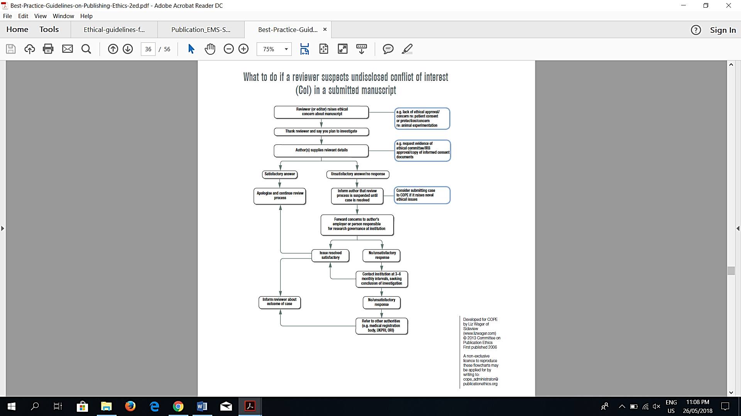

**What to do if you suspect an ethical problem with a submitted manuscript**

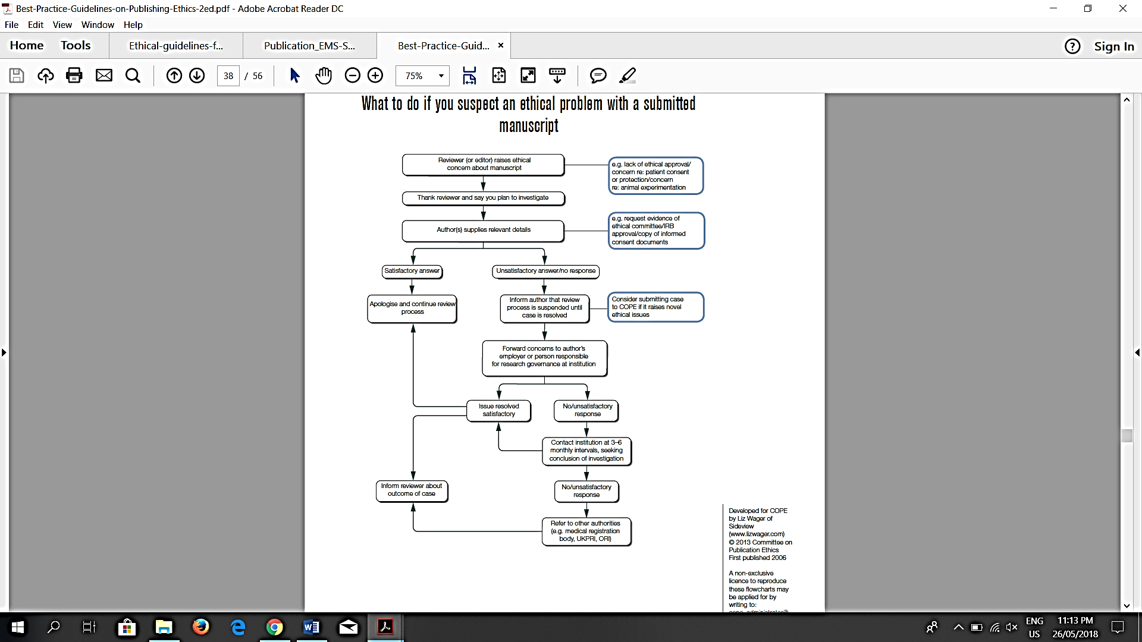

**What to do if a reader suspects undisclosed conflict of interest in a published article**

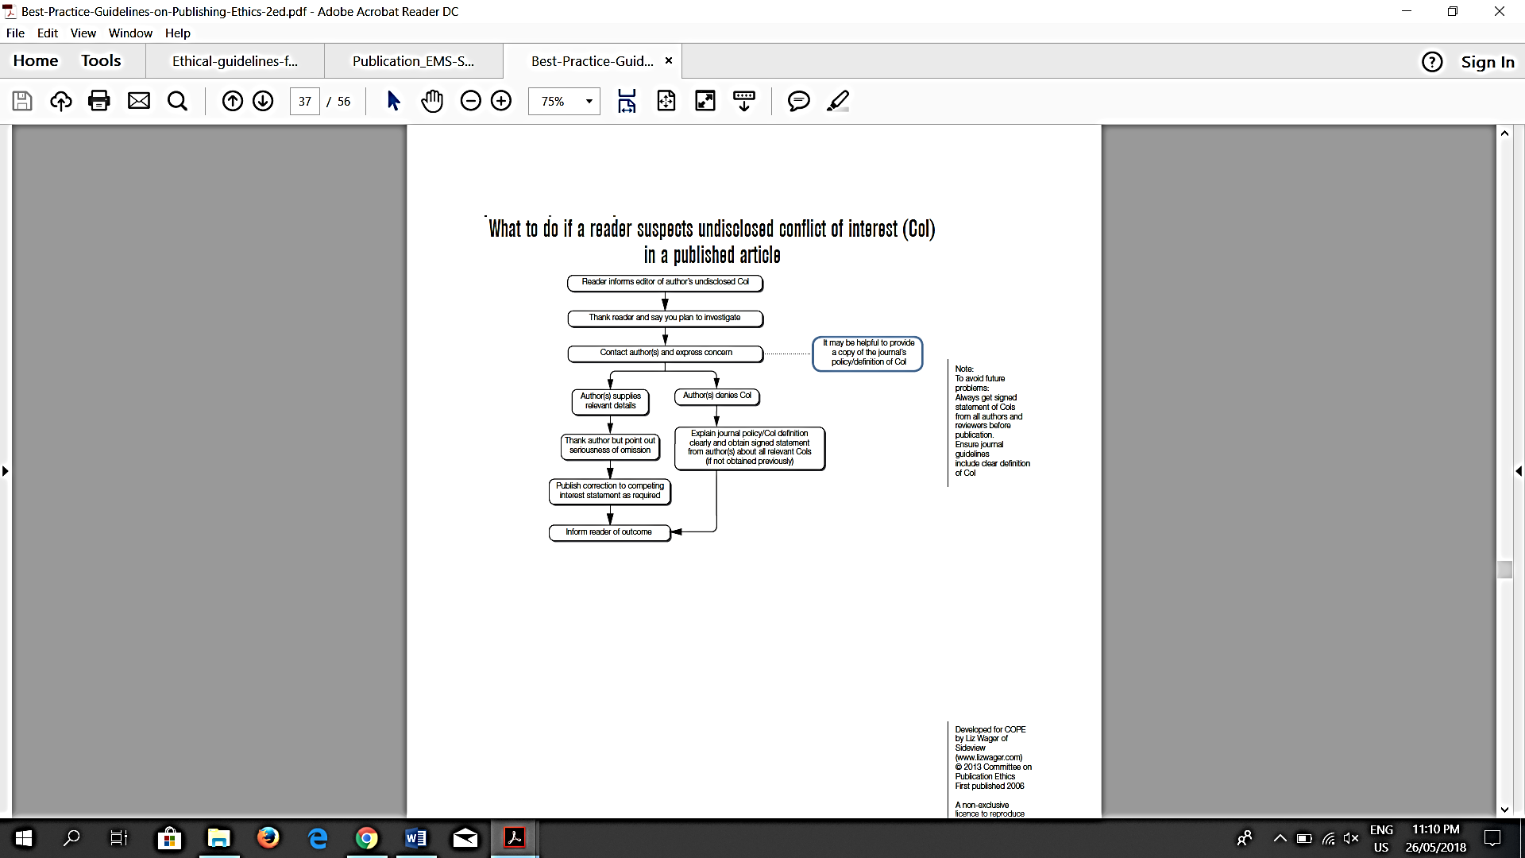

**Editorial team,**

**July 2022**